|  |  |  |
| --- | --- | --- |
| **Contact info** |  | [name] |
| EMAIL  PHONE NUMBER  LINKEDIN URL   |  | | --- | | **Objective**  Motivated and detail-oriented HR professional with a recent [Degree, e.g., Bachelor’s in Human Resources] seeking an entry-level HR Generalist position to apply knowledge of HR practices, recruitment, and employee relations to support and grow  within a dynamic HR team. | | **SKILLS**   * **HR Knowledge**: Recruitment, Employee Onboarding, HRIS (e.g., [List any HR software if known, like BambooHR or Workday]), Employee Relations * **Communication:** Strong written and verbal communication skills, experienced in managing candidate and employee inquiries * **Organizational Skills:** Detail-oriented, capable of managing multiple tasks and maintaining accurate records * **Technical Skills:** Proficient in Microsoft Office Suite (Word, Excel, PowerPoint), basic HRIS knowledge * **Interpersonal Skills:** Team player, empathetic listener, culturally sensitive | |  | |  | | --- | | **PROFESSIONAL Experience** HR INTERN **[Company Name], [City, State]** Dates From – To  * Screened 50+ resumes and scheduled 20+ interviews monthly to support the recruitment process. * Prepared­­ and organized onboarding documents for 10+ new hires, ensuring a smooth transition for new employees. * Managed employee records, ensuring 100% accuracy and compliance with company policies. * Conducted research on HR policies, contributing to the improvement of 2 internal procedures.  HR ASSISTANT VOLUNTEER **[Company Name], [City, State]** Dates From – To  * Assisted in recruiting 15+ volunteers for various events, improving team coordination and productivity. * Maintained confidential information for 20+ volunteers, ensuring compliance with data protection regulations. * Supported the planning and execution of 3 training programs, enhancing volunteer skills and knowledge. | | **Education** Bachelor of [Degree, e.g., Business Administration with a focus on Human Resources][School], [CITY, STATE] [Month/Year] - [Month/Year]   * Relevant Coursework: [List 2-3 relevant courses, e.g., Talent Acquisition, Employment Law, Organizational Behavior] * [Optional: GPA (if above 3.5), Honors, or Academic Achievements] | | **PROJECTS**  **[Project Name, e.g., Employee Onboarding Improvement Plan]**   * Designed a mock onboarding process that streamlined new hire integration, potentially reducing onboarding time by 20%. * Conducted in-depth research on onboarding best practices and presented findings, receiving positive feedback from 100% of the audience. | |

[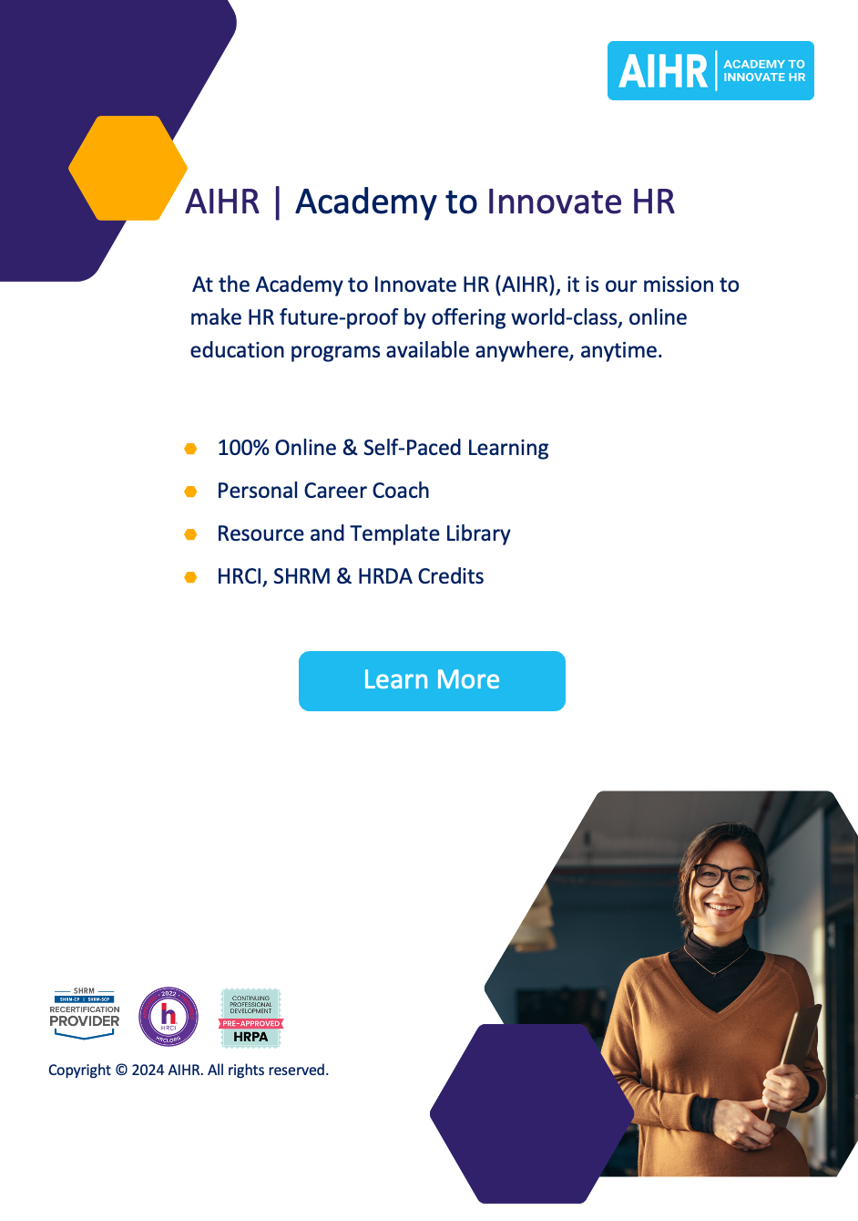](https://www.aihr.com/platform/?utm_source=resource&utm_medium=resource&utm_campaign=templates&utm_content=templates)