**HR SOP Template**

**[Company Name]**

1. Purpose

The purpose of this SOP is to outline the process and procedures for [specific HR function, e.g., "Onboarding New Employees"]. This document aims to ensure that all necessary steps are completed efficiently and in compliance with company policies and applicable laws.

2. Procedure

The step-by-step process to be followed:

**Step 1: Offer acceptance**

* HR sends the official offer letter to the candidate.
* The candidate signs and returns the offer letter.

**Step 2: Pre-employment documentation**

* HR sends pre-employment forms (e.g., tax forms, confidentiality agreements) to the candidate.
* The candidate completes and returns the forms.

**Step 3: Background check**

* HR conducts a background check as per company policy.
* If the background check is clear, HR proceeds to the next step.

**Step 4: Orientation scheduling**

* HR schedules the orientation session and informs the new hire of the details.
* Prepare the necessary materials for orientation (e.g., employee handbook, ID badge).

**Step 5: Onboarding and training**

* The new employee attends the orientation and begins the training program.
* HR ensures all onboarding tasks are completed (e.g., setting up email, workstation).

3. Responsibilities

* **HR Manager:** Oversees the entire onboarding process, ensures compliance with company policies, and addresses any issues that arise.
* **Recruitment Specialist:** Sends the offer letter, collects pre-employment documentation, and schedules background checks.
* **Training Coordinator:** Prepares orientation materials, schedules training sessions, and monitors the new hire's progress during the training phase.
* **IT Department:** Sets up the new hire's workstation, email, and necessary software before the first day.



4. Time frames

* **Offer acceptance:** Within 7 business days of the verbal offer.
* **Pre-employment documentation:** Sent out by HR within 5 business days after receiving the signed offer letter. Completed and returned by the candidate within the following 5 business days.
* **Background check:** Completed within 7 business days after receiving the signed offer letter.
* **Orientation scheduling:** Scheduled at least 5 days before the new hire's start date.
* **Onboarding and training:** Orientation on the first day, basic training to be completed within the first 30 days of employment.

5. References

* **Employment form templates:** [Links to the templates]
* **Employee handbook:** [Link to the employee handbook]
* **Company onboarding policy:** [Link to onboarding policy]
* **Local employment law compliance:** [Links to relevant labor laws]

6. Documentation

The process must be documented as it is carried out. Record the completion of each step in real-time in the HR management system. Ensure that all relevant details, dates, and any deviations are accurately captured.

7. Compliance and quality control

All steps outlined in this SOP must comply with local, state, and federal employment laws. The HR department will conduct quarterly audits to ensure adherence to this SOP, and any discrepancies will be addressed immediately to maintain compliance and improve the onboarding process.

|  |
| --- |
| **Version control:** V1  **Last reviewed date:**  **Reviewer:** [Name and/or Title]  **Next review date due:**  **By reviewer:** [Name and/or Title] |



[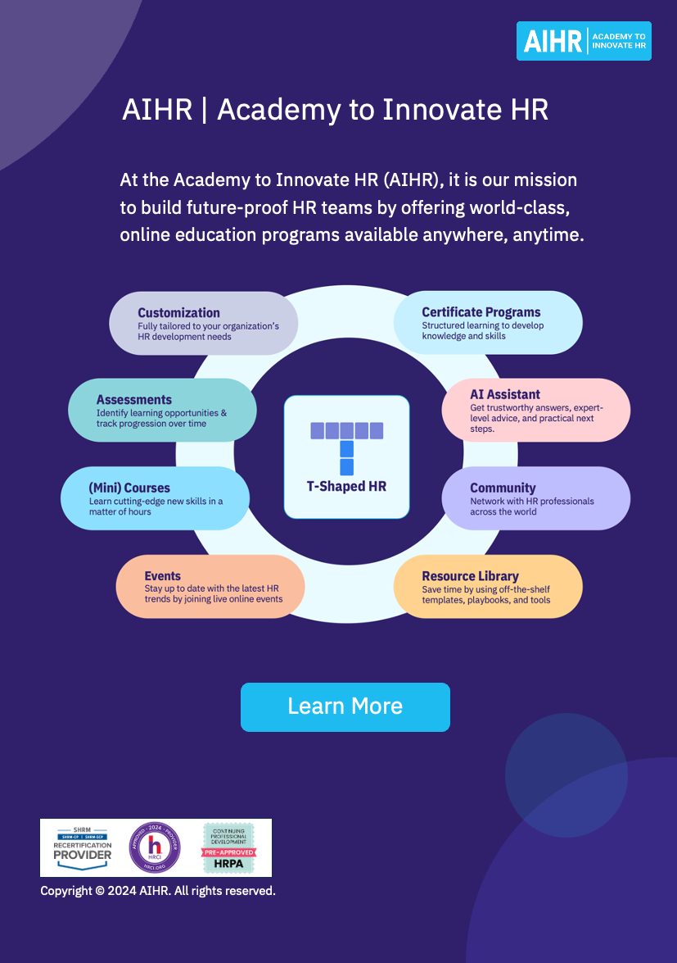](https://www.aihr.com/business/?utm_source=resource&utm_medium=resource&utm_campaign=templates&utm_content=templates)